### Dawlance DWFP-1200 Food Processor

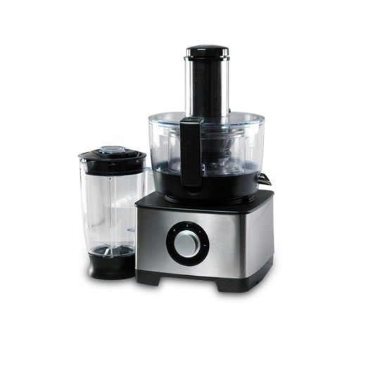

|  |  |
| --- | --- |
| **Color:** | Black/Grey |
| **Capacity(l):** | 1.8l |
| **Functions:** | 12+ |
| **Power Supply(W):** | 1200W |
| **Speed Settings:** | 4 |
| **Materials:** | Stainless Steel |